Note: This document is “view only”. Please create a copy of this document and save it to your drive.

**SOP- Tracking Time - Systems Vault**

**PREREQUISITES**

[Master : SOP- Team Member Training & Ongoing - Systems Vault](https://docs.google.com/document/u/0/d/1ehsSFDBKm1GDYCPYGj_QW-rHjlUrTM5uk6D0EKqtfQM/edit)

[Teamwork PM](http://sarahnoked.com/teamwork)

**PURPOSE**Time reporting helps us allocate the right resources to the right tasks, keeps us on track with project completion and within budget.

**POLICY**

Time tracking is mandatory for all SN staff and contractors via the Teamwork PM time tracking tool.

Time should be tracked on all assigned tasks, including weekly meetings.

In addition to the Teamwork PM time tracking tool, contractors may use an additional billing tool with a synced time tracker. Upon onboarding, contractors must confirm their method for time reporting with the Online Business Manager.

If you have a specific retainer or package you must explicitly discuss and have written permission from Sarah Noked or the Operations Manager to exceed the agreed upon retainer. If you are anticipating needing more or less time contact the Online Business Manager via [Teamwork PM](http://sarahnoked.com/teamwork) Chat as early as possible.

**PARTY**

All Team Members

**PROPERTY**

Online Business Manager

**PROCESS**

Part 1: Track time per task

Part 2: Logging time for meetings

Part 3: Report Time *\*for contractors*

**PROCEDURE**

**Part 1: Tracking Time**

1. Login to [Teamwork PM](https://sarahnoked.teamwork.com/)
2. Navigate to your daily tasks: Home > My Work > Today
3. Upon opening a task, click on “Start Timer” and proceed with the work required to complete the task.
4. Upon completion, click on “Log Time”.
5. TIP: You can have multiple timers saved throughout the day, if you need to move between tasks you can simply pause the timer in the previous task and start on the next.

**Part 2: Logging time for Meetings**

1. There are a number of meetings that occur weekly - under each meeting task list you’ll find a recurring task list to log your time spent at that meeting.
2. To get to your meeting tasks go to [Teamwork PM](https://sarahnoked.teamwork.com/) > [Projects](https://sarahnoked.teamwork.com/#/projects/list/active) > [Strategy & Agendas](https://sarahnoked.teamwork.com/#/projects/593929/tasks) > Navigate to the meeting list in the bar on the left hand side of the page > navigate to the weekly recurring task list > scroll over the task list and click on the clock icon > start timer/log time

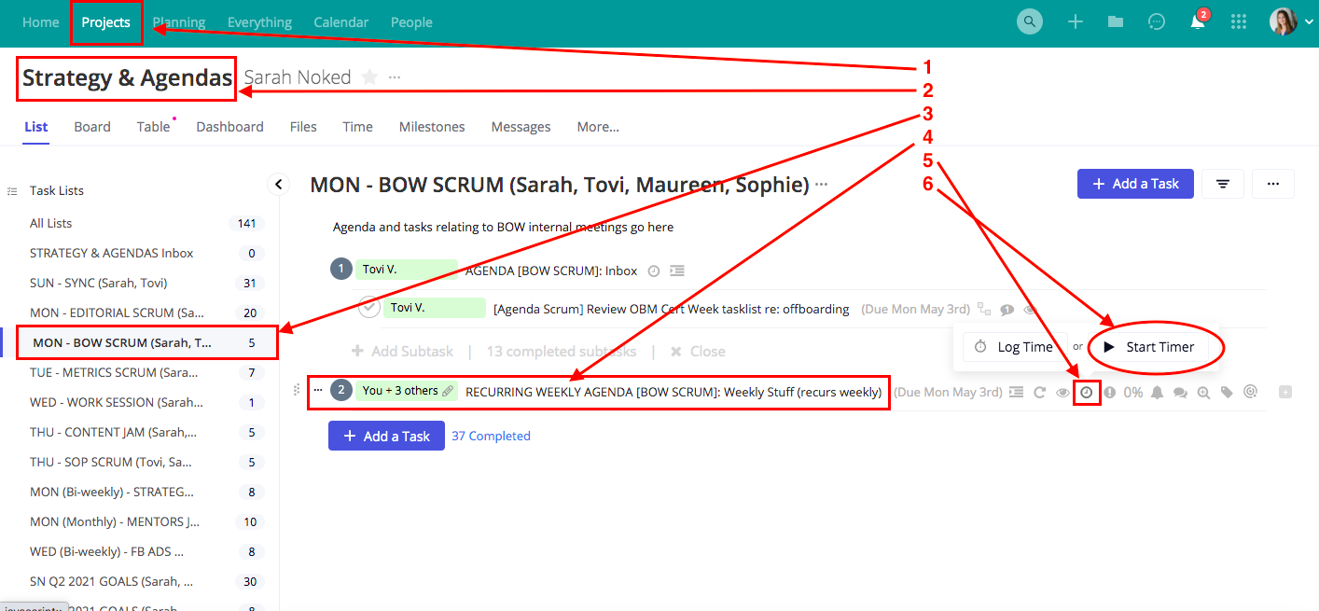

**Part 3: Reporting time *\*for contractors***

1. Navigate to your recurring task to report time
2. Submit your time report via the agreed upon time report tool in the task comments

**Created by:**

**Department:** Growth

**Date:**

**Revised:**

**Revised by:**